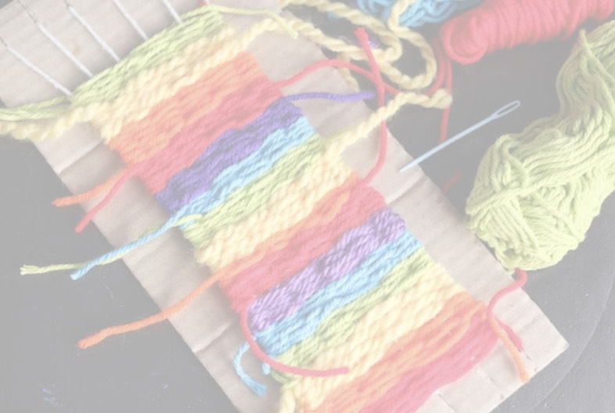
Fiber Fiesta
Material List
Project 1: Weaving – cardboard generally 8”x10” (a shipping box works great), yarn, plastic needle, and scissors.
Project 2: Tube knitting – 10 popsicle sticks, paper towel or toilet paper tube, 2 elastic bands, white glue, yarn, and scissors.
Project 3: “Painting” with fabric – 1 package of cheese cloth (same as you get at the supermarket), white glue, scissors, and colored paper 8”x10”.
Project 4: Worry dolls – 6 pipe cleaners, yarn or embroidery floss, fabric scraps, and scissors.
PLEASE NOTE:
YARN: The yarn can be any color it should be worsted weight (medium weight). The same yarn can be used for all the projects.
PLASTIC NEEDLE are optional. Here where to find one if you would like: https://smile.amazon.com/Pieces-Colorful-Plastic-Needles%EF%BC%8CSafety/dp/B07SM6WTHN/ref=sr_1_2?crid=3Q7NC4MOI756L&dchild=1&keywords=plastic+needles+for+kids&qid=1588797613&sprefix=plastic+need%2Caps%2C520&sr=8-2
POPSICLE STICKS: https://smile.amazon.com/hand2mind-Vibrant-Classroom-Supplies-Homeschool/dp/B07YNF8RYK/ref=redir_mobile_desktop?ie=UTF8&aaxitk=wIEjjHG2JEkfRkZ9jAoyDA&hsa_cr_id=7653210690501&ref_=sb_s_sparkle

