Curb-Side Ceramics Services
The Umbrella will begin firing services and clay sales on Tuesdays and Thursdays, weekly until we are able to re-open.*Please note the building is closed, and no services are available that require entrance by anybody

Purchasing Clay:

Clay must be purchased online. The cost is $35 per 25lbs and includes firing services. Once an order is placed, you will be notified by email when items can be picked up. You must confirm via email the date in which you will be picking up the clay. If a material is out of stock, you will be informed, and given the option to switch clays, or wait until the next shipment arrives. If you are unable to pick up the order between 10am-5pm, Tuesdays or Thursdays, please contact Mike for special arrangements.

The Clays we will have available are:

White Stoneware 20231

Porcelain 92700

Sculpture Clay S-14

Speckled Clay T-360 M

“Black Clay” Standard 266

Brooklyn Red Standard 266

Clay Pick Up:

Once you have purchased the clay online, you will receive an email confirming the pick up date. It is very important that you respond to the email in order to have your clay brought out. Clay will be placed in the back parking lot in the designated spots labeled for clay pick-up. The clay orders will be organized by last name, reserving the space to the Left of the clay for Names beginning with A-L, and the parking space on the Right labeled for M-Z. If there is a line of cars making pick-ups, please remain in your car, and wait for the parking space to become available. Do not park elsewhere and walk over to the clay area! We are using the parking spaces to ensure social distancing!

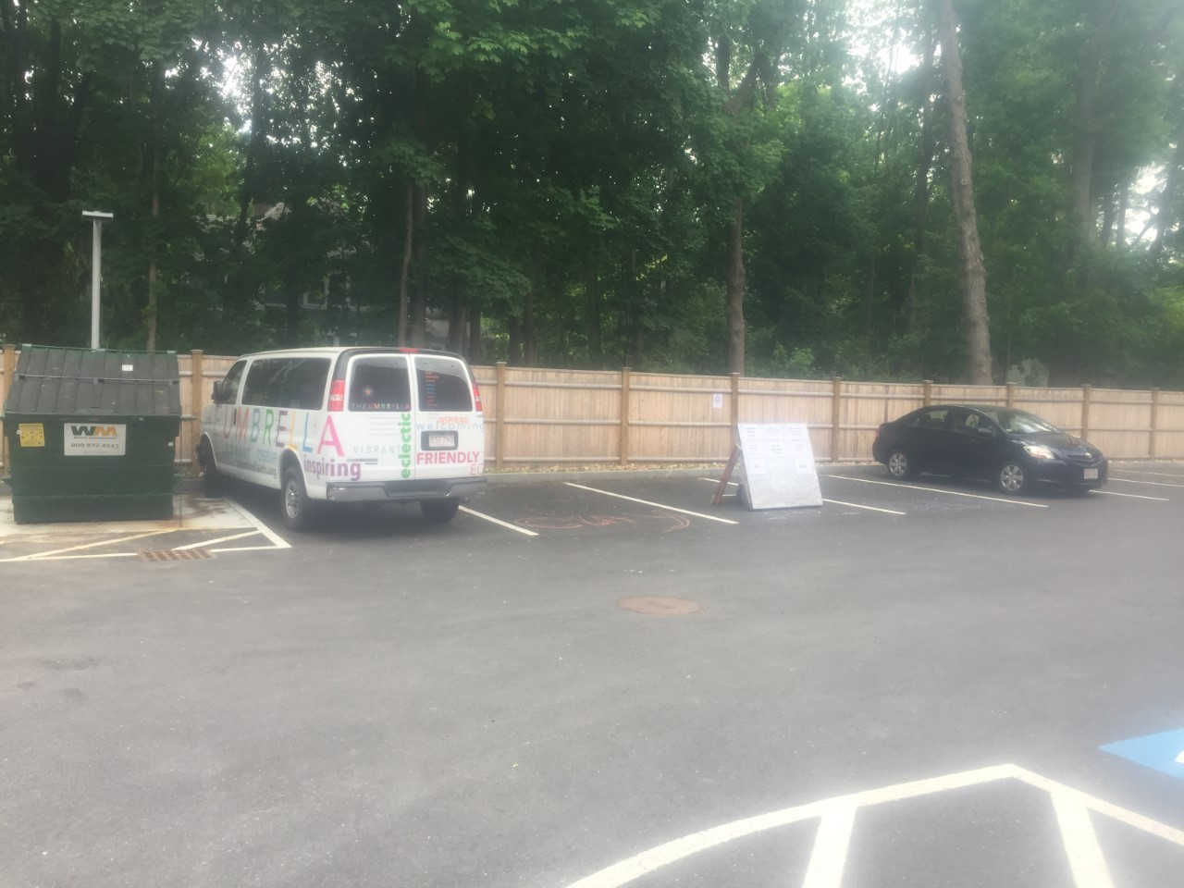

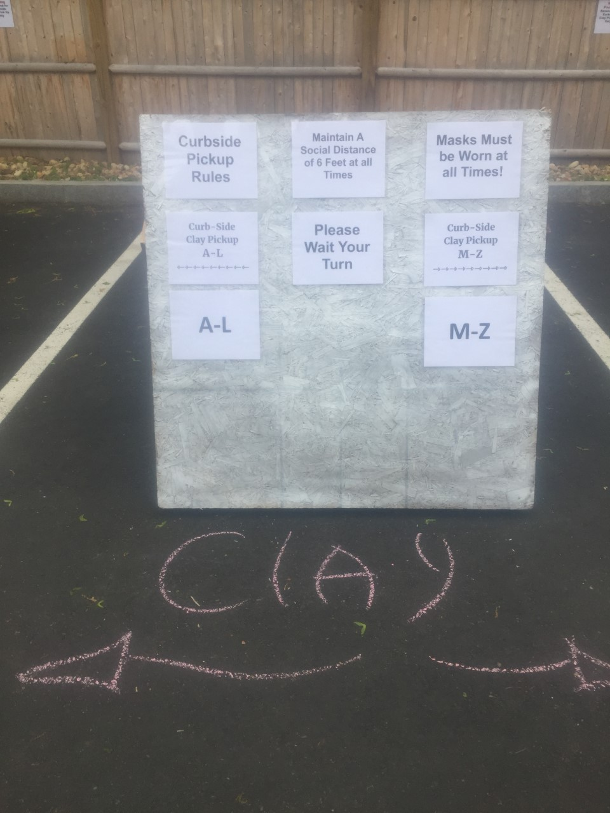
Dropping Off Greenware:
*Do not drop of greenware if it is raining or it looks like rain! The Umbrella is not responsible for any damage to clay caused by weather during drop off or pick up

Drop off Greenware on the mobile racks located on the patio outside of the ceramics studio. You are welcome to either park in the back parking lot, or on the street for your convenience. The studio will be checking on carts hourly to ensure there is enough space to accommodate all of our members. Works will be fired in the order they arrive, and are expected to have a 3 week turn around. Please take all packing material with you, and leave nothing on the racks except your work. Works must be picked up promptly in order to maintain the storage and safety of wares. Bisque-ware can only be kept for 1 month after it has come out of the kiln and will be recycled or discarded after the time allotment.
* If you see Mike, please know he wants to be able to talk with you, but must maintain distance. He will be limiting his in person interactions to keep everybody safe, but is happy to answer any questions, or just say hello through email!

Broken Pieces: As we all know, clay can break, either in transport or in the kiln. It is very difficult to be in communication over broken wares during these times, so unfortunately, we will employ the following system until we can be more articulate:

All Broken pieces will be fired and placed on the pick-up racks. We will not be leaving any notes or explanations if things occur, but please know we will do our best to take the utmost care of your wares. We apologize in advance if items break, and look forward to getting back into our former, safer systems of facilitating pottery. Thank you for your patience and understanding.
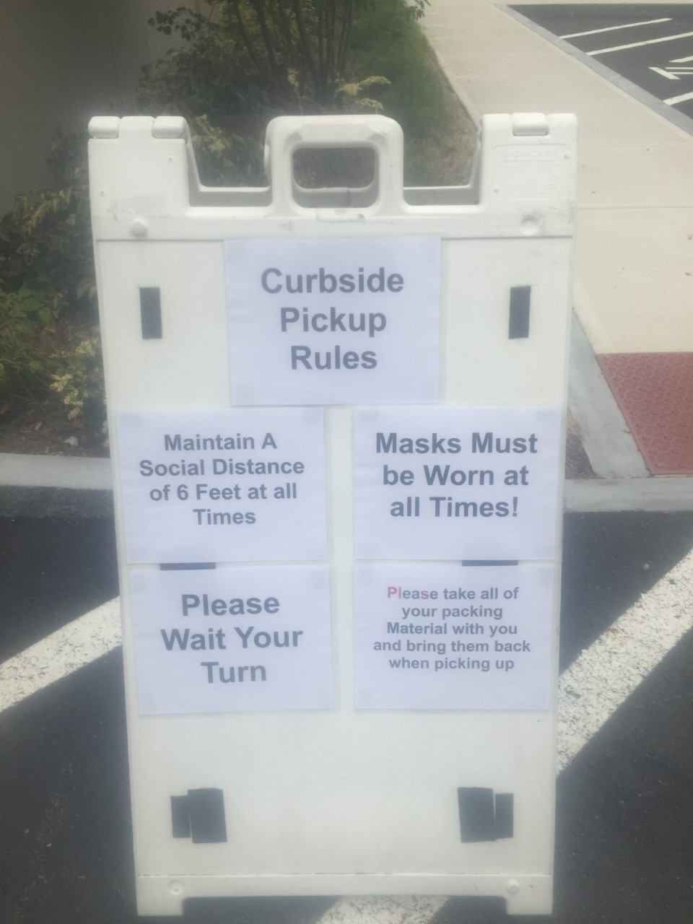
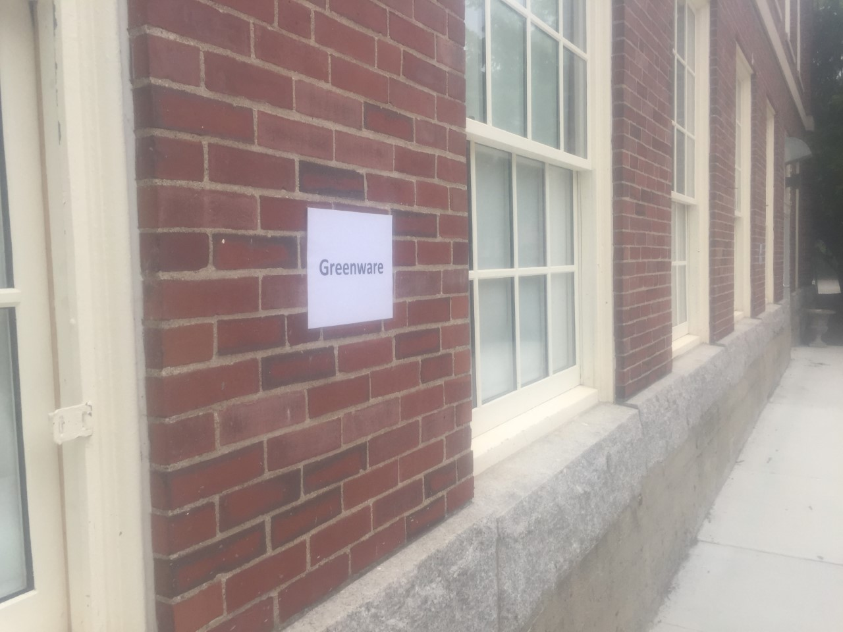

Picking up Bisque-ware

Bisque-ware is located on mobile racks on the patio alongside the main studio. Members must bring their own packing materials, and are highly encouraged to wear gloves when picking up wares. Racks will be spaced 6 feet apart to allow for social distancing. If another member is currently picking up, you must wait for your turn to go through the racks! Social distancing must be maintained at all times!

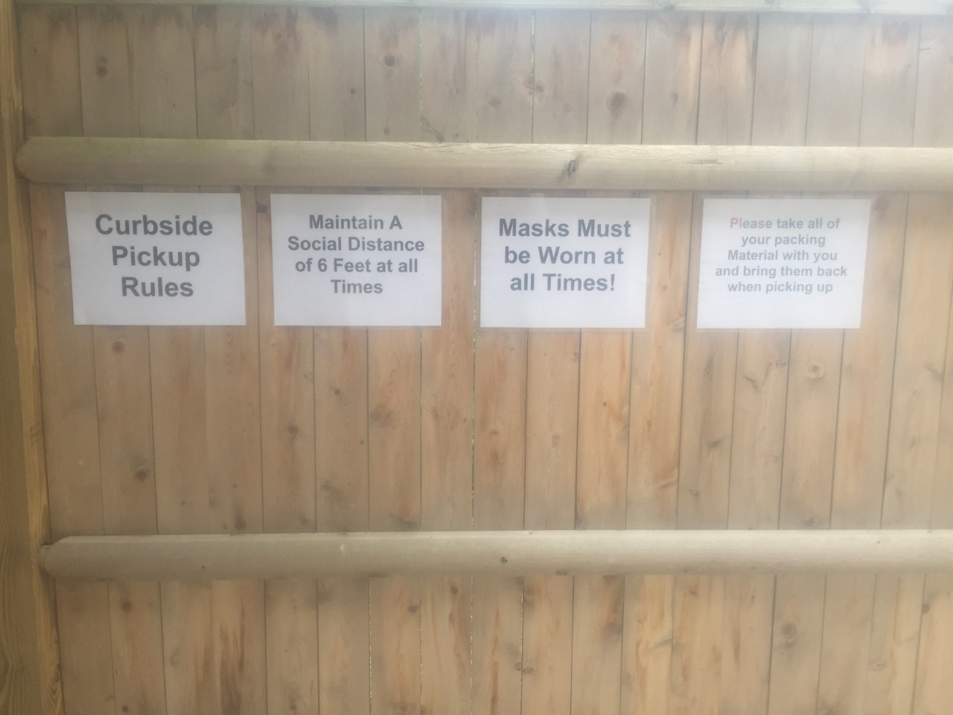

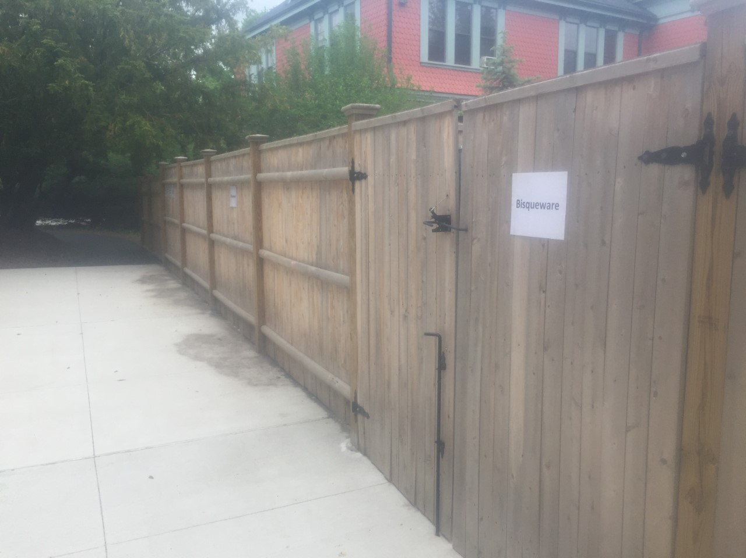

Glaze Services

All use of studio glazes are suspended until we are back inside of the studio building. As the glaze is included in the price of your clay, you will not be charged for glaze when we re-open. When safe to do so, we will offer paid, drop in glaze session to use the interior studio space to complete your works . If you would like to purchase commercial glazes from elsewhere, and have them fired here please contact Mike in advance with what glazes you are using and place them on the designated cone 6 racks on the ceramics drop off patio. Finished Wares will also be available for pick up along the side patio. Please contact Mike in advance to discuss any special needs regarding glaze firings and drop off options.

Cleaning & Additional Safety Measures
Racks will be disinfected daily, or every time they exit the kiln room. The biggest way to help keep ourselves safe is to pick up your bisqueware quickly! Try to limit touching pieces that aren't yours, and consider wearing gloves. The quicker works get picked up, the less crowded the racks are, which means there is a greater chance you will be able to access your work, without having to move any other pieces around.

Paying for Firing Services

If you purchased clay from an outside vendor, we charge a firing fee of $1 per lb. of wet clay. For convenience many people pay per bag of clay, meaning they will pay $25 for a standard, 25lb bag, rather than weighing the clay and paying incrementally. We try to limit outside sales as it complicates our system, but we greatly appreciate your honesty in paying for your firings! Please drop off any firing payment in the form of a check in the payment box beside the greenware racks. Your $25 fee includes a glaze firing, but will not include glaze until the studio is allowed to have members enter the building . If Clay was purchased through the Umbrella there is no additional firing fee.

Please email mike for any further questions about the process!

